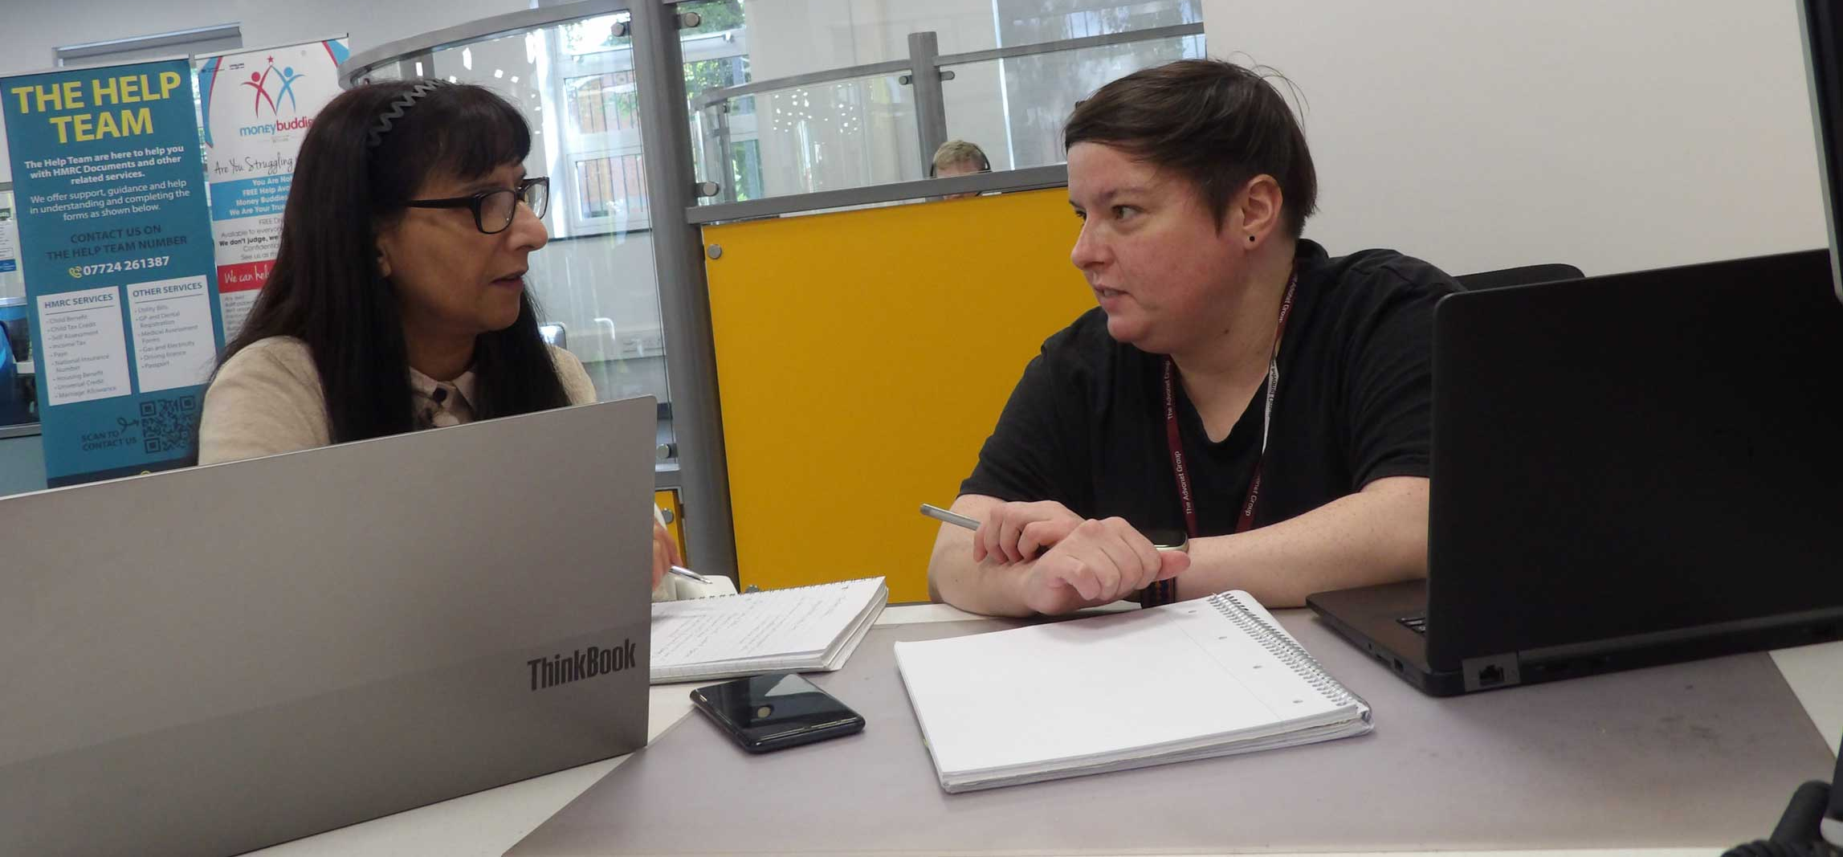

What is the Self-Advocacy Toolkit?
Self-advocacy is the ability to speak up for yourself. It means you are able to tell people what you think and feel. It helps other people to understand what is important to you. The self-advocacy toolkit gives you different ways to ask for what you want and need.
This is important. Being heard means that you are able to be part of decisions that are being made about things that affect you and make sure that your rights in any matter are upheld.
This toolkit can be used to help you get your views, wishes and opinions across to others.
It will help you to be at the centre of your care and support, and to play an active part in decision making for issues that affect your life.
Self-Advocacy Toolkit

- Help you make a plan for what you want to say at meetings, about you or the services you receive.
- Help you plan phone calls and get your point of view across clearly.
- Consult with professionals about your views and wishes and tell them what is important to you.
- Raise issues and complaints with services that provide care or support to you.
- Make a complaint to help solve problems.
What can the Toolkit help me to do?
Consulting (or discussing) is the way in which agreements can be made so you can get the most suitable service or care for you, or for someone you are helping.
The Local Authority (council) or NHS services and all professionals or practitioners should consult with the person about their proposed (or already provided) care and/or support services.
Consulting
Step 1: Identify your goals | Step 2: Gather information
- What MUST you achieve?  - What would you LIKE to achieve?  - What is your ‘bottom line’?  - What would you settle for?  - What would you absolutely NOT settle for? | - What information do you need to be able to consult with them?  - What information will they need from you?  - Are you aware of any information they might have that could influence the consulting i.e. funding issues?
Step 3: Points to consider
- What allowances could I make that would still get a good result?
- What allowances could I ask that they make, that would help to get a good result?
- Do I need to ask for advice? E.g. Citizens Advice or similar?
- Where would I feel most comfortable when discussing my care or support?
- Would I need to have someone with me when discussing? Who might this be?
Step 4: Use the template or planner that suits your needs

Meeting Planner

How to use this document: Plan for an important meeting you have. Say what the meeting is about, who it is with and what you want from it. This planner also has bits where you can write what you want to say and what happened after your meeting.
The meeting could be about something important. It could be about your housing, support, health, money or access to a service you want to use.

What is the meeting about?
In this section, say what the meeting is for. Example: “The meeting is about applying for a new council house”

Who is attending the meeting today?
Please write the name and job title of the person or people you are meeting with. Example: “Name: John Johnson”, “Job title: Mental Health Coordinator”
Name:
Job title:
Name:
Job title:
Name:
Job title:

What do I want to say?
Write about what you want to tell people in the meeting. Example: “The house I live in now is too cold and unsafe”
What do I want to happen?
Write about what you want to happen in the meeting and afterwards.
Example: “I want to know if I can repay my debt in instalments”
Things I do not want to happen:
Write about what you don’t want to happen in the meeting. Example “I don’t want to be told ‘no’ when asking for support”

Actions:
Say what you have done after your meeting here.
What has happened e.g. “Fill in an application form” | What you want to happen next e.g. “Get my PIP application approved”
Notes: Write down anything else important that you think should go here. Example: “Check my bank balance to see if I have been paid”

Phone Call Planner

How to use this document: Plan for an important phone call you are making or waiting for. Say why it is important and what you want to say in it.
This planner has bits about what you want to say in your phone call. There are also sections for what you want to get from the phone call.
At the end, there is a section for what to do after the phone call and who can help you with it.

What is the phone call about?
In this section, say what the phone call is for. Example: “The phone call is about booking an appointment with an emergency dentist”

Who am I calling?
Please write the name, job title and phone number of the person or people you are calling. If it helps, write down the day and time of the phone call.
Example: “Name: John Johnson”, “Job title: Mental Health Coordinator”
Name:
Job title (if it’s relevant):
Phone number:
Day of call:
Time of call:

What do I want to say?
Write about what you want to tell people in your phone call. Example: “The house I live in now is too cold and unsafe”
What do I want to happen?
Write about what you want to happen on the phone and afterwards.
Example: “I want to know if I can repay my debt in instalments”
Things I do not want to happen:
Write about what you don’t want to happen in the phone call. Example “I don’t want to be told ‘no’ when asking for support”

Actions/Outcomes:
Say what needs to happen after the phone call. Also say what has happened and when it was done by. Use the columns below to write them down.
Actions - What has happened e.g. “Fill in an application form” | By whom and when e.g. “By my  advocate - on Friday 19th February”
Notes: Write down anything else important that you think should go here. Example: “Check my bank balance to see if I have been paid”

Please Take Note: Part 1

How to use this document: Write about an issue you need help with. This is to give to an organisation or service you want to access or get help from.
Say what you want the person you need help from to know. Say what you would like to happen after they read your note.
At the end of Part 1, there is a section about who you want help from. If you need support from someone, this is really useful.

My name:
Date of note:
Time of note:

To: (The person the note is for)
Job title:
Company/
organisation:

What I would like you to know:
In this bit, say what you want people to know about what you want and need. Example: “I need to access counselling to help me understand my autism”

What I would like to happen and by when:
In this bit, say what you want to happen. Then, say when you would like it to happen. Example: “I would like to move to a new house in six months”
Who I would like to help me with this:
In this bit, say who you want help from to achieve your goal/goals. Example: “I need a support worker to help me access mental health support”

Please sign and photocopy this sheet for my file:
Your signature:
Job title:
Date:

Please Take Note: Part 2

How to use this document: If you are working with someone using Part 1 of this tool, please use it to make sure their wishes are met.
Use this part of Please Take Note to write down what you have done for them. It should be based on what they have told you in Part 1.
Write any actions you need to take. Then, write any results or outcomes based on those actions.
Please only use Part 2 if you are a professional working with the person who filled in Part 1.

Staff member name:
Date of note:
Time of note:
Client name:

Actions taken:
In this bit, say what has been done based on the notes in Part 1. Example: “The client has been given information about a local food bank”

Results/outcome:
In this bit, what has happened after your actions. Example: “After answering the client’s phone call, I have given them details to join a Zoom group”

Please sign and photocopy this sheet for my file. Then, give this copy back to the client.
Your signature:
Job title:
Date:

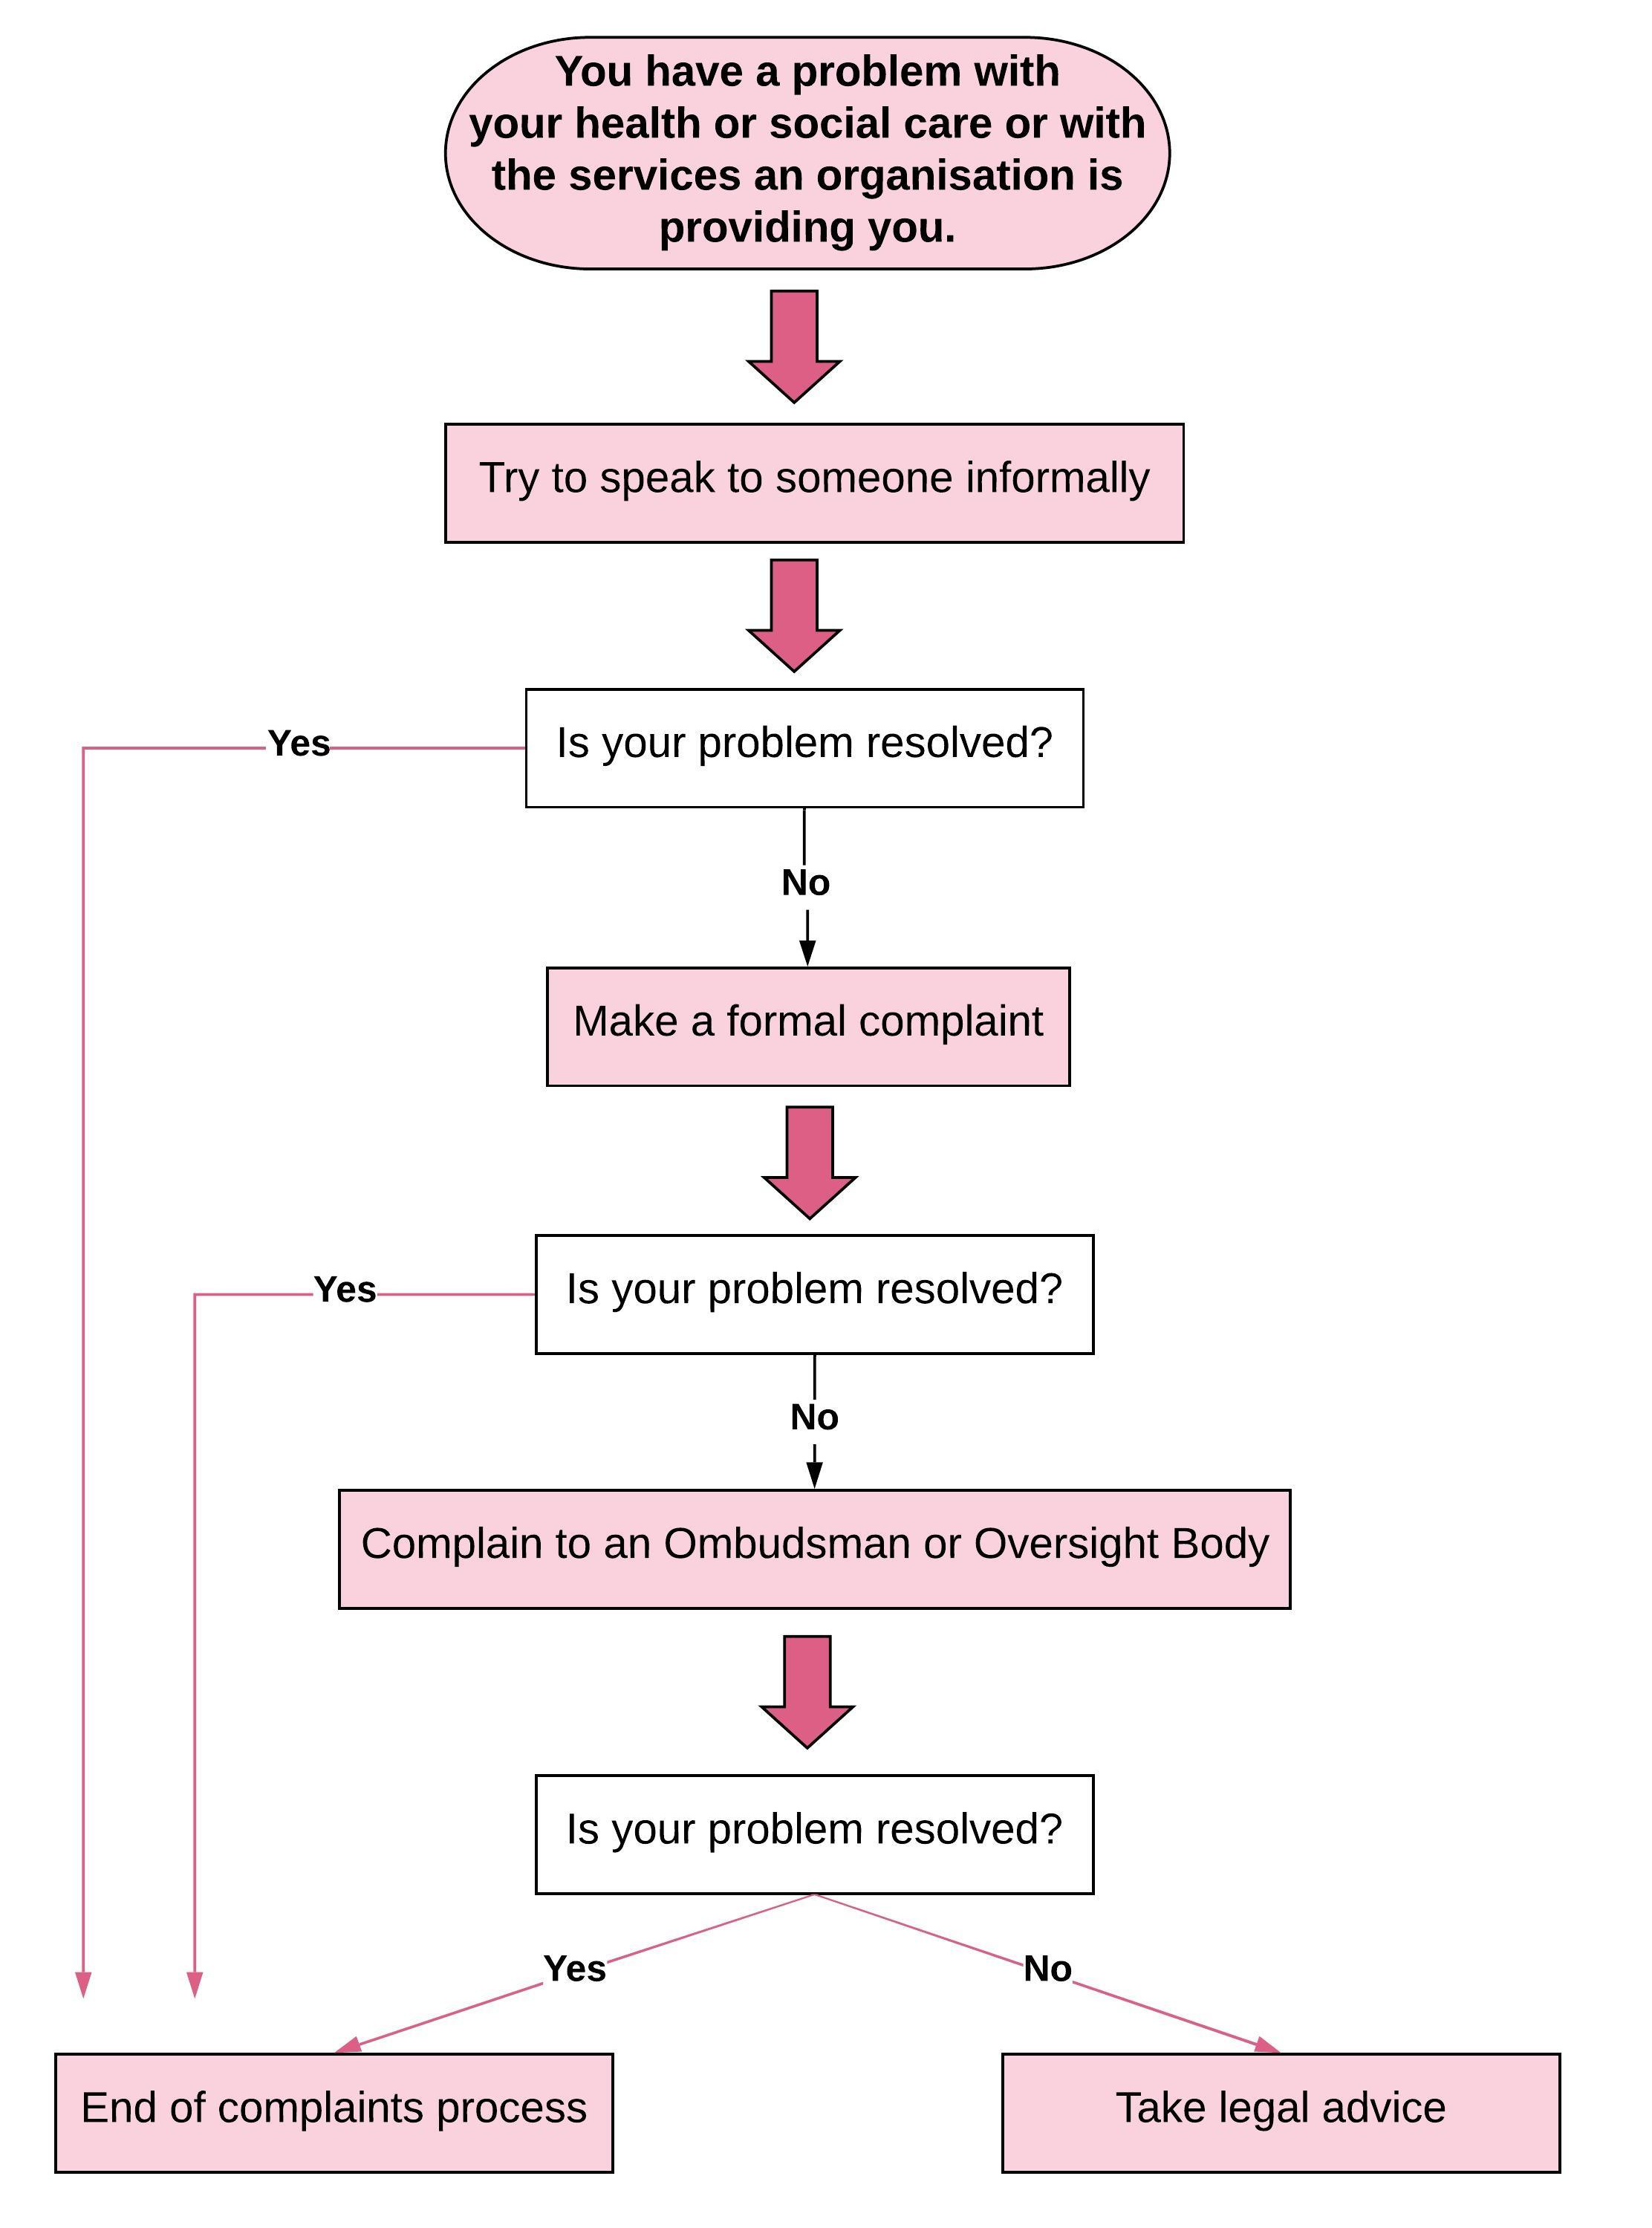
Formal complaints process chart

Complaint Template

About this document: This is a template to help you write a complaint. It could be for a service you have used that did not help you. It is set up like a letter. You can send a completed one to a service you want or need to complain about.
The start of the letter
At the start, there is space for your address. There is also space for the
address of the person or organisation you are complaining about.
After that, there is space for you to start the letter. It begins with “Dear...”. In this bit, you should write their name e.g. Mr. Smith.
The line below should say what your complaint is about. At the start of the
letter, you should say what you are complaining about in more detail.
Please find an example below of what the start of the letter could look like.

01/02/2026
Dr N Smith, GP
Streetville Medical Practice
26-28 Street Avenue
Streetville
West Yorkshire
LS45 0MB
01/02/2026
Mr Peter Petersen
12 Street Road
Streetville
West Yorkshire
LS45 1HW

Dear Mr. Smith
Ref: Complaint regarding being given the wrong medication
I am writing to you in order to make a complaint about being prescribed the wrong medication for my asthma.

What you want to say next
After the first bit of the complaints letter, you should go into detail about your complaint. Here are a few tips to help with that, with some examples:
• Use facts to back up your complaint. Try to sound calm and avoid using words about your feelings. If it helps, use bullet points for each fact.
• Example: “I felt that I was made to wait too long for an appointment. I was promised I would be seen in 10 minutes. I waited 45 minutes.”
• Say what exactly went wrong. Say what has or has not happened. Say what has happened because of the problem. Bullet points can help.
• Example: “The medication I got didn’t work for my arthritis. I was told by my GP that it would work.”
• Add times/dates for when specific things happened. Names of key workers and others involved can help. Say who told you and what they said.
• Example: “At 1pm on Monday 1st March, I was told to leave my home.”
• Write down any information you were given before the problem happened. Say what you were told to expect, if it’s useful.
• Example: “Housing said I would be on the waiting list for a month.”
• Say what you have already done to try and fix the problem.
• Example: “I tried to space out my doses, but it did not work.”
• Add any copies of important letters, documents or evidence you have.
• Example: A photocopy of the letter with your first meeting date
• Say what you want to happen and when to fix the problem.
• Example: “I would like a new appointment by Friday 26th February”

The end of the letter
At the end of your complaint letter, think about writing in a friendly way. In it, say that you hope to hear back from them soon.
It should not have too many words it. Before writing your name at the end, it might be worth saying something like “Yours sincerely”. This makes it more likely that you will get a reply to your complaint.
You should end any complaint letter with your name. This makes it look more professional. It also makes it more likely that you will get a reply.
Here is an example of what you could write at the end of your complaint:
I would be grateful if you would respond to me in writing at the above given address to confirm receipt of this complaint at your earliest convenience.
I look forward to hearing from you in the very near future.
Yours sincerely,
Your name goes here

Template letter examples
Citizens Advice have some examples on their website of template letters used for things like complaints.
Their template letters can be used for many different types of complaint you may need to make.
Templates are there for complaints about services and things like money, energy and faulty goods.
You can download them for free at these links:
• https://www.citizensadvice.org.uk/consumer/template-letters/letters/

Complaint template: How it looks

Date and Year
Mr/Mrs/Ms/Dr. Specific Person
Job title
Address
Postcode
Date
Date and Year
My name
Address line 1
Address line 2
Postcode

Dear……………………………………………………………………………………
Ref: Complaint regarding ……………………………………………………
I am writing to you in order to make a complaint about;
• Use facts to back up your complaint. Try to sound calm and avoid using words about your feelings. If it helps, use bullet points for each fact.
• Say what exactly went wrong. Say what has or has not happened. Say what has happened because of the problem. Bullet points can help.
• Add times/dates for when specific things happened. Names of key workers and others involved can help. Say who told you and what they said.
• Write down any information you were given before the problem happened. Say what you were told to expect, if it’s useful.
• Say what you have already done to try and fix the problem.
• Add any copies of important letters, documents or evidence you have.
• Say what you want to happen and when to fix the problem.
I would be grateful if you would respond to me in writing at the above given address to confirm receipt of this complaint at your earliest convenience.
I look forward to hearing from you in the very near future.
Yours sincerely,

Contact Us
If you have any questions for us about our Self-Advocacy Toolkit, please contact get in touch. You can reach us by:
- Calling our office on 0113 244 0606
- Emailing our team at office@advonet.org.uk
- Visiting our website at advonet.org.uk
We also share other resources on our social media accounts:
- Facebook
- Instagram
- Bluesky
- LinkedIn

Our self-advocacy resources are inspired by those made by South West Advocacy Network (SWAN)

