|  |
| --- |
| **JOB TITLE:** CHANGE Enterprise Manager |
| **DATE PRODUCED:** July 2025 |
| **TEAM:** CHANGE |
| **DIRECT REPORTS:** 2 |
| **REPORTING TO:** Development Director |
| **DIRECT FINANCE:** CHANGE Budget |

**Location:** Your base will be the Advonet office at The Unity Business Centre.However, Advonet has a flexible working approach, meaning that employees can work at home and in other locations that best meet the needs of the service. We also have an expectation that colleagues will meet with colleagues and clients in person as well as online. For this role, our expectation is that you would be meeting people in person and working from different locations in Leeds including the Advonet office at least 8 times per month, with occasional meetings further afield. This will include attending meetings that are relevant to your role and organisational needs

**Job Purpose**

The CHANGE manager will oversee and develop our CHANGE social enterprise model which focuses on building income from accessible information resources.

CHANGE has an over 20 -year history nationally of empowering marginalised groups and in particular ensuring information is accessible for people with learning disabilities. You will develop the social enterprise to increase sales of bespoke commissioned easy read products and increase take up of subscriptions to our easy read image bank, as well as following up physical sales and our training offers.

You will lead a small team of designers/ illustrators, project staff and Words to Pictures volunteers to achieve this, with support of the Advonet Development Director and wider Advonet team.

**Main Duties and Responsibilities**

**Marketing CHANGE products to increase sales/ income**

1. Promoting and marketing CHANGE products including its bespoke, commissioned work, easy read subscriptions, physical product sales, quality checking and training offers.
2. Maintaining and building stakeholder engagement. This will include using social media at increase reach, creating regular posts, blogs and webinars suited to the target audience. It will also include attending conferences, meetings and sector specific events to develop brand recognition and conversion to sales.
3. Identifying, prioritising and following up leads and building relationships with a range of potential buyers including public sector, VCSE and corporate clients to increase sales of areas above.
4. Monitoring and managing the CHANGE website, ensuring it is an effective platform for sales.
5. Exploring wider income generation opportunities, with support of the Development Director/ CEO.

**Quality**

1. Ensuring consistent quality of CHANGE products and services, identifying any issues and developing improvements where needed.
2. Tracking competitors offers and trends and keeping track of new developments such as in AI, exploring innovation where needed.
3. Ensuring CHANGE work/ products are well linked across the wider organisation.

**Line Management**

1. Providing effective line management support for the CHANGE designers/ illustrators and supporting to manage workload.
2. Supporting the Words to Pictures project worker and volunteers and overseeing their work.
3. Ensuring the development and training needs of CHANGE staff are met through PDRs and regular one to ones and having oversight, planning actions for any volunteer training/ development needs.

**Project Management**

1. Ensuring project plans are up to date and regularly reviewed, acted on to achieve project goals.
2. Ensuring timely delivery and tracking progress of work, liaising with the wider CHANGE team and commissioners/ buyers.
3. Managing the CHANGE budget with support of our finance team, tracking income and costs and taking action where needed.

**Organisational Responsibilities**

1. Uphold and promote the organisation's values of Kindness, Inclusivity, Accountability, Diversity, and Empowerment in all aspects of work (see image below).

2. Ensure all activities comply with safeguarding policies and procedures.

3. Participate in team meetings, training, and organisational development initiatives.

**Person Specification**

| **Essential Criteria** |
| --- |
|  |
| 1. Strong interpersonal and communication skills, including the ability to network and present confidently with a range of professionals and organisations 2. Equally able to communicate to senior professionals from a range of professions, Board members and people with disabilities. 3. Ability to create project plans, track progress and take action to amend planning as needed to reach project goals. 4. Ability to prioritise sectors and leads within these, following these up to convert to sales. 5. Proficiency in using and tracking the impact of social media to increase reach and sales, including in creating blogs and webinars. 6. Ability to track budget lines, identify issues and take action where needed. 7. Good technical understanding of website functions to achieve targets and ability to articulate requirements and commission these from a web team pro-actively to resolve issues. 8. Ability to empower a team and support their development, following policies. 9. Ability to track wider changes in easy read provision and trends and use this to inform planning and development. 10. Ability to work autonomously and confidence managing upwards 11. Ability to develop and lead training 12. Commitment to the principles of co-production, valuing lived experience 13. Flexible and adaptable to project needs 14. Ability to demonstrate commitment to Advonet values.   **Desirable Criteria**   1. Experience of supporting or working alongside staff or volunteers with disabilities 2. Knowledge of barriers/ communication needs of people with learning disabilities 3. Knowledge of e –commerce platforms 4. Understanding of the easy read model and approaches. 5. Confidence in leading/ facilitating events |
|  |
|  |
|  |

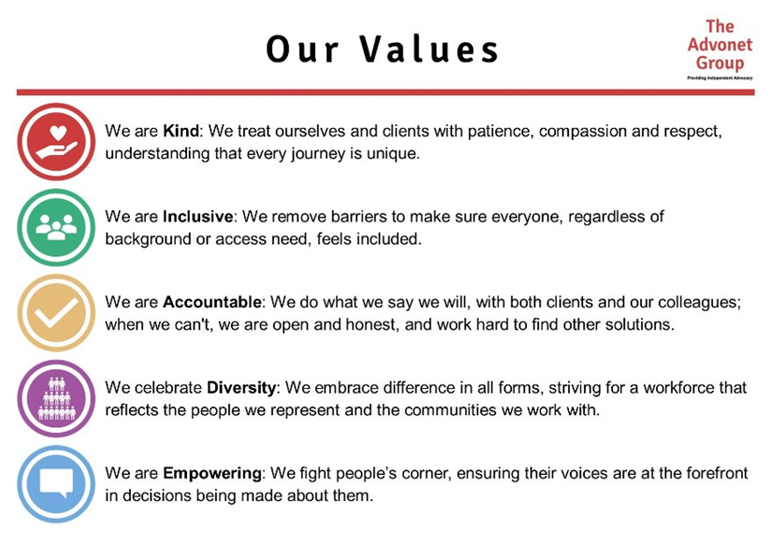

**About Us:**

The Advonet Group values and respects the diversity of backgrounds, experiences and knowledge that staff, volunteers and job applicants bring. All our staff undertake mandatory training on both Equality and Diversity and LGBTQ+ Awareness to increase awareness and understanding of discrimination both in and out of the workplace, with a view to reduce the impact this has on our colleagues and the wider community. This creates a workplace where staff feel comfortable to be themselves and empowers them, and our service users, to use their unique experiences to inform their work.

|  |
| --- |
| **SIGNATURES:** |
| **JOB HOLDER:** |
| **MANAGER of JOB HOLDER: Wendy Cork** |