Advonet: Job Application Form
What is the job you have applied for?

 | Important notes
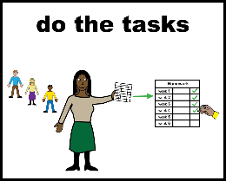  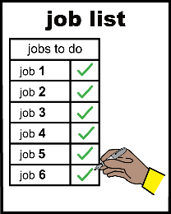 | Thanks for your interest in working for Advonet.  Please read these notes before filling in this form.  There will be a recruitment panel for the interview.  The panel will have someone who has used an Advonet service before.  To help them know more about what you can do, please write clearly.  Please read the information first. This includes the Job Description and the Person Specification.  You can type in the form.  Give all the information you can about yourself.  Say why you think you can do the job.  It should match what is in the Person Specification.  When you finish the form, please send it to Advonet.  You can email it to jobs@advonet.org.uk.  You can also post it to this address:  Advonet  Unity Business Centre  26 Roundhay Road  Leeds  LS7 1AB

Personal Contact Details
Your full name
Your postal address
Your phone numbers
Day number:
Evening number:
Mobile number:
Your email address

References
If you get on the shortlist, we will ask for references from people who know you.

Please give names and addresses of two people.

They should be people who know you well enough to say if you can do the job.

One referee should be the person you most recently worked for or volunteered with.

Please say how you know each referee.

You cannot have a friend or family member as a referee.

You won’t be offered a job until good references have been received.
Please write your old name and job title (if you have one)

 | Referee 1
 | Referee’s Name
 | Referee’s Job title
 | Who the Referee works for
 | Referee’s address
 | Referee’s email address
 | Referee’s telephone number or mobile phone number
 | How does the referee know you?
 | Can we talk to the referee before your interview?
 |  | Yes ☐ |  | No ☐
 | Referee 2
 | Referee’s name
 | Referee’s Job title
 | Who the Referee works for
 | Referee’s address
 | Referee’s email address
 | Referee’s telephone number or mobile phone number
 | How does the referee know you?
 | Can we talk to the referee before your interview?
 |  | Yes ☐ |  | No ☐

 | Education and Qualifications
Please say what your education and qualifications are.
Education and Qualification Details |  | Result or Grade | Where did you get it? | When did you get it?

 | Training and Development
Please say if you have any professional qualifications. Please also say if you are a member of a professional group.
 |  |  |  | 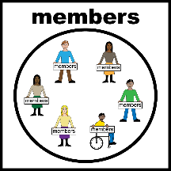
Name of qualification or professional group |  | Level | How did you get it? | When did you do it?

 | Do you have a full, current Driving Licence?
 |  | Yes ☐ |  | No ☐

 | Language Skills
Which languages do you speak and/or write?
These do not include English.
Click or tick the box if you write or speak the language.
Name of language |  | I speak it | I write it
 |  | ☐ | ☐
 |  | ☐ | ☐
 |  | ☐ | ☐
 |  | ☐ | ☐

Work History:
Your most recent job
Health care assistant
Please write about your current or most recent job here.
Employer’s Name and Address
Name of job |  |  |  | When did you have that job?
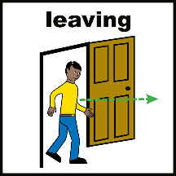  Reason for leaving |  |  |  | Wages and hours worked
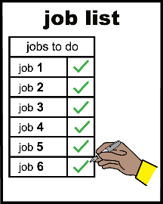
List of duties in this job

Work History:
Your earlier jobs
Please write about any other jobs you have had here.
Employer’s Name and Address
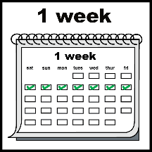
Name of job and weekly hours worked there
Your pay and dates/
time worked there
Reason for leaving
Employer’s Name and Address
Name of job and weekly hours worked there
Your pay and dates/
time worked there
Reason for leaving
Employer’s Name and Address
Name of job and weekly hours worked there
Your pay and dates/
time worked there
Reason for leaving
Employer’s Name and Address
Name of job and weekly hours worked there
Your pay and dates/
time worked there
Reason for leaving

Please write about any other jobs you have had in the space below.

 | Under immigration law, are you currently allowed to work in the UK?
 |  | Yes ☐ |  | No ☐

Supporting Information
Please write down anything else about you that you want to say in this job application form.
You could talk about things like your skills or hobbies that might help you in the job.

 | Where did you hear about this job?
 | Website | Email | Other
 | ☐ | ☐ | ☐
 | Please say where you heard about it – which website or organisation told you?

Please write down all criminal convictions you have that are not “Spent”.

Advonet will follow the Rehabilitation of Offenders Act 1974.

If you are successful, we will do an Enhanced DBS Check on you.

 | I confirm that as far as I know, the information I have given in this form is all correct:
 | Signed: | Date:

