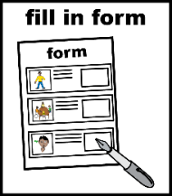
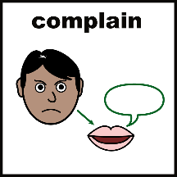
Complaints and Compliments Feedback Form
This form is for when you want to make a complaint about an Advonet Group service.
It is also for if you want to say something good about an Advonet Group service.
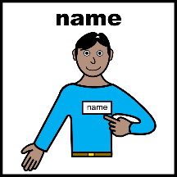 | Name
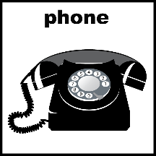 | Home and mobile phone numbers
 | Email address
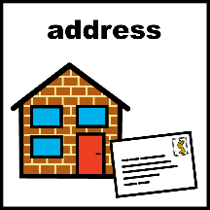 | Postal address
 | Brief details of your complaint or compliment. These should include dates and names if they are important.
 | If this is a complaint, what would you like to happen to sort it out?

How would you like us to contact you?
☐ | ☐ | ☐

Do you need any support to make your complaint?
Yes  ☐ | No  ☐
If you said ‘Yes’, please tell us what help you need

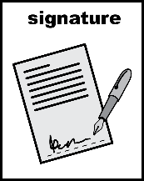
Please sign below to show you understand all this information and agree with how we will store your details.
Print name
Signed |  | Date

