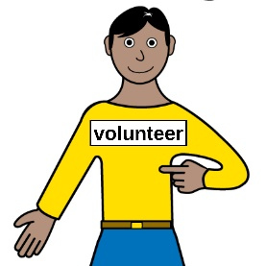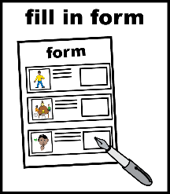

Volunteer Application Form
 | About You
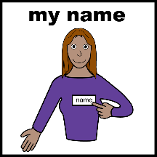 | Your name:
 | Your home address:
postcode | Your postcode:
 | Your phone number: |  |  |  | Your mobile number:
 | Your email address:
 | What are your pronouns? These are the words to say what your gender is
She/Her/Hers ☐ He/Him/His ☐

They/Them/Theirs ☐ Prefer not to say ☐
 | I prefer to use other pronouns: Please write down below
 | Your date of birth – write it like this – 03/04/1982
Are you interested in any of these volunteer roles?

If you are, please tick the box or boxes you like.
 | ☐  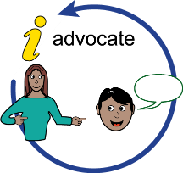 | Learning Disability Citizen Advocate |  | ☐ |  | Leeds Autism AIM Autism Mentor
 | ☐ | Leeds Autism AIM Autism Hub Supporter |  | ☐ |  | Community Advocate
 | ☐ | Advonet Trustee |  | ☐ |  | Asking You! Volunteer
 | ☐  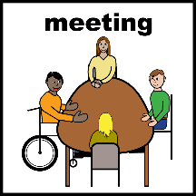 | Meeting Support Volunteer |  | ☐ |  | LEEP1 Volunteer Activities Supporter
 | ☐ | Cafe LEEP Volunteer Support Assistant |  | ☐ |  | Advonet Fundraiser & Events Organiser
 | ☐ | CHANGE Board Member |  | ☐ |  | CHANGE Words and Pictures Group Volunteer
 | ☐ | Don’t know |  | ☐ |  | Other – please write it down in the box below:
 | Where did you hear about volunteering with Advonet?
☐ Volunteer Centre Leeds (Voluntary Action Leeds)
☐ Doing Good Leeds Website
☐ Volunteer Connect Website
☐ University/College
☐ Advonet Website
☐ Advonet Newsletter
☐ Social Media
☐ Internet Search
☐ Word of Mouth
☐ Other Charity or Community Organisation – please write it down below:
 | ☐ Other - please write it down below:

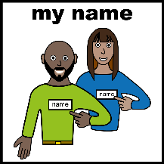 | Your Referees  Please name two people we can contact to give references for you. Referees are people who know you.  They must not be a family member or someone you live with. They must have known you for at least 6 months.
 | Referee 1
 | Referee’s Name
 | Referee’s Job title
 | Who the Referee works for
 | Referee’s address
 | Referee’s email address
 | Referee’s telephone number / mobile phone number
 | How does the referee know you?
 | Referee 2
 | Referee’s name
 | Referee’s Job title
 | Who the Referee works for
 | Referee’s address
 | Referee’s email address
 | Referee’s telephone number / mobile phone number
 | How does the referee know you?

Please check that the people you have named are able to give references for you.
Additional Information
Why do you want to volunteer?
What is your past experience? What are your skills?
Do you have any qualifications?

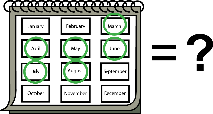 |  | When can you volunteer?  Please write down the days and times that you are free to volunteer in the table below. For example, 9am-11am in the Monday morning box.  Usual Advonet working hours are Monday-Friday, 9am-5pm. However, some evening and weekend work might be needed. This depends on the role.
Monday
Tuesday
Wednesday
Thursday
Friday
Saturday
Sunday

 | Please feel free to tell us anything else about when you are available:
Write down here.

Health information

Are there health or disability issues that might affect your volunteering?

Are there any adjustments we could make to help you in your role?

Please let us know if you would like to talk about it privately with the right Volunteer Coordinator.
 | Write down here.
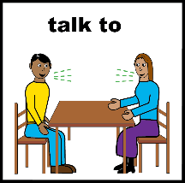 | Criminal convictions  Are there any Criminal Cautions or Convictions that you think we should be aware of and that you would like to talk about in private?  Yes ☐ No ☐  As part of your application, we have to do an Enhanced DBS (Disclosure and Barring Service) check.  This is to protect the interests of the people who use our service.  There are some voluntary roles where this may not be needed. The Volunteer Coordinator will talk about this with you.  Please note that if offences that were not mentioned in your application form are shown in your DBS check, your application will be turned down.

 | I confirm that as far as I know, the information I have given in this form is all correct:
 | Signed: | Date:

Office Use Only:
Date received: | Primary Volunteer Coordinator: | Volunteer Role Agreed:

