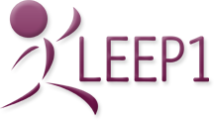
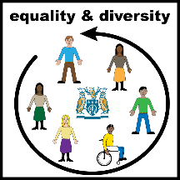
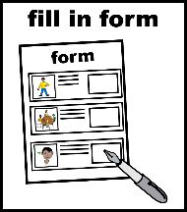
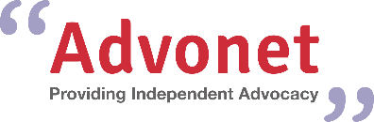

Advonet: Equal Opportunities Form
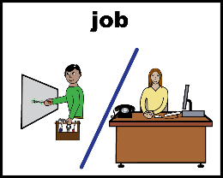 | Job Applied For:

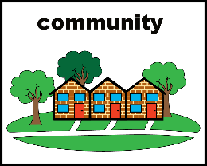  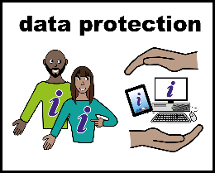  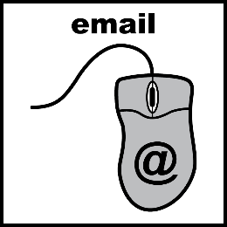  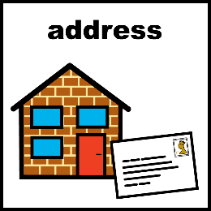 | We want to have a workforce that is like the communities we work with.  We are committed to making job opportunities equal for people from all parts of the community.  To make sure we do that, we ask to give information about you.  We will only use it for administration. It will be kept safe.  Please keep this form separate from your job application form.  You can email it to jobs@advonet.org.uk.  You can also post it separately to this address:  Advonet  Unity Business Centre  26 Roundhay Road  Leeds  LS7 1AB

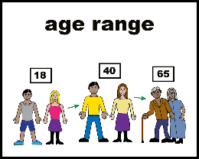 | Which age range are you in?
 | Under 16 | ☐ | 16-17 | ☐ | 18-24 | ☐
 | 25-29 | ☐ | 30-34 | ☐ | 35-39 | ☐
 | 40-44 | ☐ | 45-49 | ☐ | 50-54 | ☐
 | 55-59 | ☐ | 60-64 | ☐ | 65-69 | ☐
 | 70 and over | ☐ | Prefer not to say |  |  | ☐

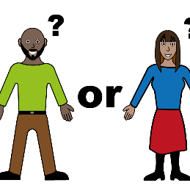 | What is your gender/gender identity?
 | 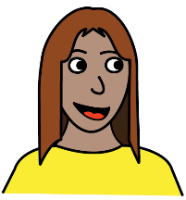  Female | ☐ | 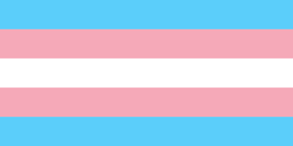  Trans Female | ☐
 | 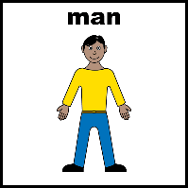  Male | ☐ | Trans Male | ☐
 | 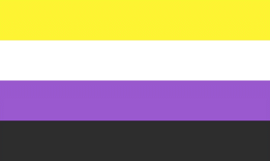  Non-Binary | ☐ | Prefer not to say | ☐

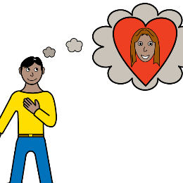 | What is your sexual orientation?
 | Asexual | ☐ | 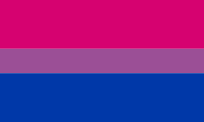  Bisexual | ☐
 | 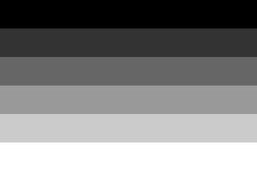  Heterosexual/Straight | ☐ | 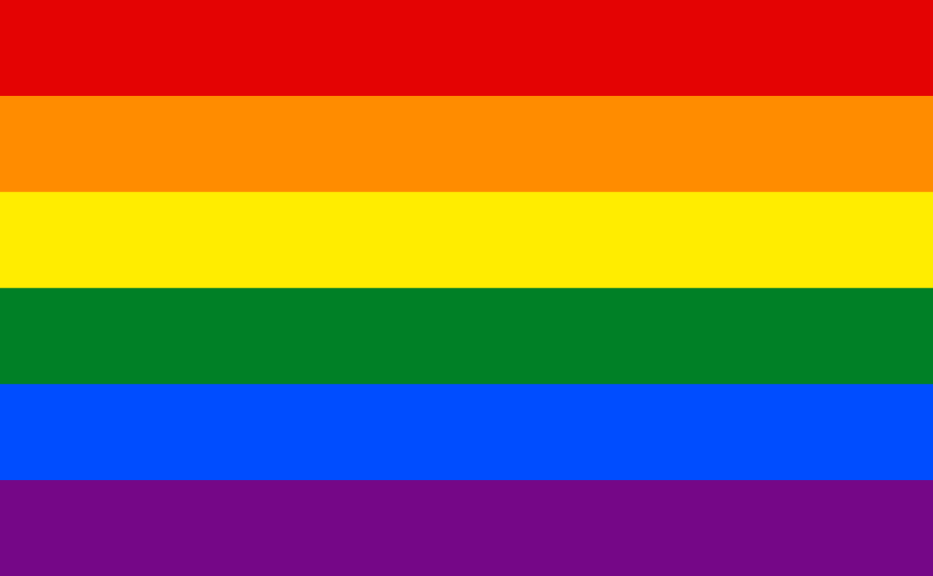  Homosexual/Gay | ☐
 | Pansexual | ☐ | Prefer not to say | ☐

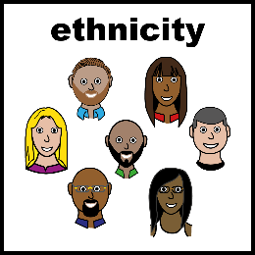 | What is your ethnicity?
 | Asian or Asian British - Bangladeshi | ☐ | Asian or Asian British – Chinese | ☐
 | Asian or Asian British - Indian | ☐ | Asian or Asian British – Kashmiri | ☐
 | Asian or Asian British - Pakistani | ☐ | Arab | ☐
 | Black or Black British – Black African | ☐ | Black or Black British – Black Caribbean | ☐
 | Eastern European | ☐ | Gypsy or Traveller | ☐
 | Mixed White - Black African | ☐ | Mixed White – Black Caribbean | ☐
 | Mixed White - Asian | ☐ | Roma | ☐
 | White - British | ☐ | White – English | ☐
 | White - Irish | ☐ | White – Northern Irish | ☐
 | White - Scottish | ☐ | White – Welsh | ☐
 | Prefer not to say | ☐ | Other – please write below | ☐

 | What is your religion?
 | 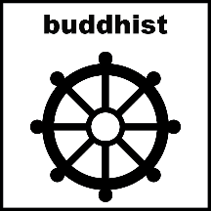  Buddhist | ☐ | 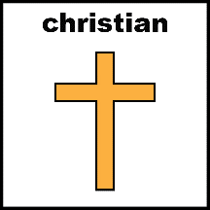  Christian | ☐
 | Hindu | ☐ | 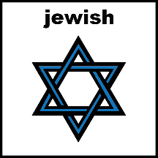  Jewish | ☐
 | Muslim | ☐ | No belief | ☐
 | No religion | ☐ | Sikh | ☐
 | Prefer not to say | ☐ | 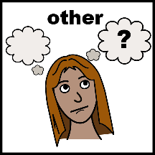  Other – please write down below | ☐

 | Do you have a disability?
 | 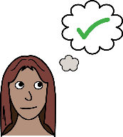 | Yes ☐ | 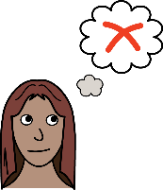 | No ☐ | Prefer not to say | ☐

 | If yes, what is your disability?
 | 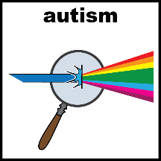  Autism | ☐ | 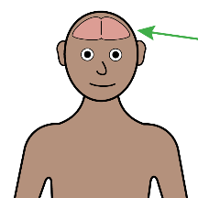  Cognitive impairment | ☐
 | 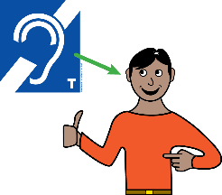  Hearing impairment | ☐ | Learning disability | ☐
 | 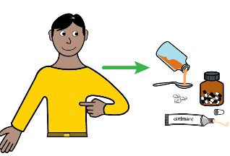  Long-term illness or health condition | ☐ | 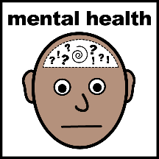  Mental Health | ☐
 | 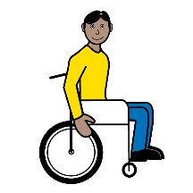  Physical impairment | ☐ | 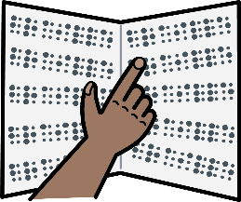  Visual Impairment | ☐
 | Prefer not to say | ☐ | N/A | ☐
 | If other or you like to use your own words, please write down here:

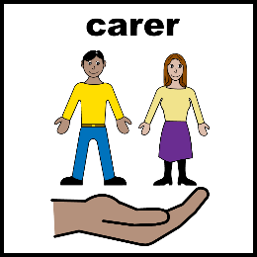 | Are you a carer?
 |  | Yes ☐ |  | No ☐ | Prefer not to say | ☐

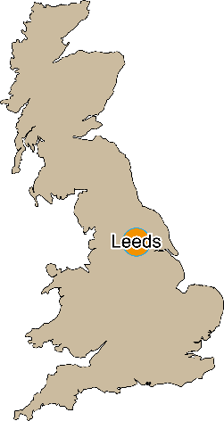 | Do you live in the Leeds City Council Area?
 |  | Yes ☐ |  | No ☐ | Prefer not to say | ☐

