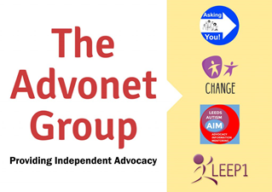
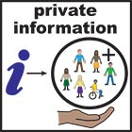

Privacy Statement for Clients
About this statement
This is about how The Advonet Group gets, stores, and uses personal data given to us by people who use our services. We call them clients.
Clients include people who need advocacy and who use other services that are part of The Advonet Group. These services are Leep1, Leeds Autism AIM and Asking You!
Please read this notice. It will help you know how and why we keep your personal data.
Personal data is information about you. It includes things like your name, address, and phone number.
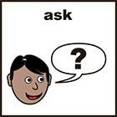 | Your Rights  The General Data Protection Regulations (GDPR) give you these rights:  - You have the right to get your personal data from us, except in limited situations  - You have the right to ask us to correct any wrong personal data we hold about you  - You may also have the right to have missing personal data completed  - You have the right to ask us to delete your personal data  - You have the right to ask us to limit processing of your personal data on certain grounds  If you would like to use any of these rights, please contact us.
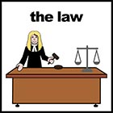 | Data Protection law  Data Protection law says personal info about you must be:  - Used lawfully, fairly, and clearly  - Used for valid purposes only  - Relevant to the purposes we have told you about  - Accurate and kept up to date  - Kept only as long as needed  - Kept securely
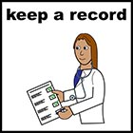  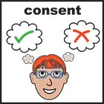  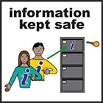 | Using your Personal Data  We will only record your personal data with your consent first. To do that, you need to sign this document first.  We will keep your name and address on our CharityLog database. We may also need to keep records from phone calls and meetings.  We may also record personal data in staff one-to-one notes. For these, we only use your initials instead of your full name.  When you first contact us, you have the choice of giving us personal details to go on our database.  You do not have to give us these details if you don’t want to. If you say “no”, we will respect that.  Only staff who work or volunteer with us can see the information in the database. They can only get into it by using their own password.  Our database is “encrypted.” This means that if someone we didn’t know tried to get into our computer system, they wouldn’t be able to see the information on it.  All our filing cabinets are kept secure behind our office door. We have policies to keep data safe and secure.  Your data will only be seen by people who need it to do their job. For example, advocates may access the database to get your contact details.
data protection officer | Linda Kelly is our Data Protection Officer.  You can contact Linda:  - By telephone on 0113 244 0606  - By email at Linda.Kelly@advonet.org.uk  - By mail at The Advonet Group address
Contact us
The Advonet Group is the data controller. We are a limited company registered in England under company number 4229975.
Our registered office is at Unity Business Centre, Roundhay Road, Leeds, LS7 1AB
You can also talk to any team member if you have any questions about data protection. They will contact Linda on your behalf.
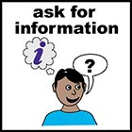 | If you want more information  The Advonet Group has a Data Retention Policy. It has more details of information we record about clients. We also have an Information Governance Policy.  Please ask a team member if you would like to see either of these policies.
I agree to The Advonet Group using my personal data in the ways said above.
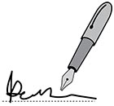
Your signature
Your name
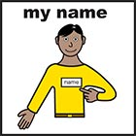
Today’s date

