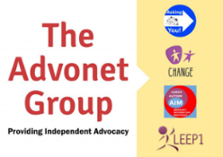
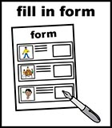
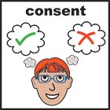

Consent Form
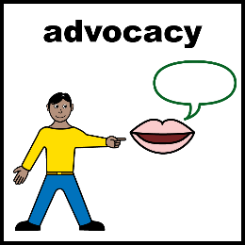 | To help you with your advocacy issue, we may need to talk to other people. We need your consent to do that.  Other people may be helping you, like a support worker. If you would like us to speak to them about your advocacy issue, please sign this form.  This will show you are okay with us asking them for more information.  If you are unable to sign the form, please ask the person filling it in for you to tell us why.  Please read the information below. Then, sign the form and put a date where it says to.
I agree that workers from The Advonet Group may speak with the people or groups named below.

This is to help me with my advocacy issue.

Organisation / Person
Organisation / Person
Organisation / Person
Organisation / Person
Organisation / Person
I have read and agree to the information above.
Your signature
Your name
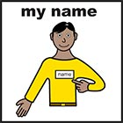
Today’s date
If you want someone you know to help you speak to your advocate. Or give us information about you. We need you to give consent.

I would like the person named below and my advocate to share information about my advocacy issue.
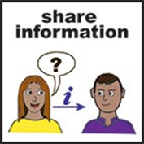 | Their Name:
Your signature
Today’s date
 | We may be sent information from the people you have said we can contact. We will keep a copy. We will give you a copy.
If you want people to send information to us at our address you will need to ask us first.
If we say you can do this we will ask you to sign a form.
This is for Data Protection. Any information sent to us about you may be opened by office staff.

