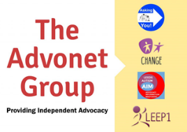
The Advonet Group Advocacy Agreement

Advocacy Agreement
What change would you like to see happen?
Make a list of the advocacy work that has been agreed with your advocate below.
What are we doing? | Who will do this? | When will they do it?
Tell us what you can do and what you find difficult to do below. This will help your advocate to support you to develop some skills and confidence so you can speak up for yourself. This is called being able to self-advocate.

What can you do? (e.g. make calls, write letters) | What do you find difficult to do (e.g. tell people what I want)

Please sign below to show you have read and agree to the work your advocate will do.

Client Names
Signed
Date | Click or tap to enter a date.
If someone is helping you please write their name below.
Person’s Name
Signed
Relationship to client
Date | Click or tap to enter a date.

