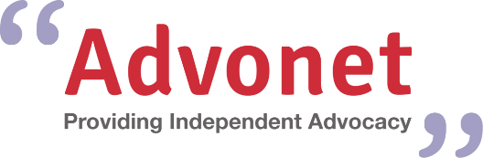
Speak4Yourself Card:
Please fill in this form
Name:
Email address:
What do you find difficult? Please write down up to six things you need help with in the box below e.g. talking to someone face-to-face, understanding jargon
How can you help me? Please write down up to six things that people can support you with e.g. being calm, speaking clearly
When you have finished this form, please email it to selfadvocacy@advonet.org.uk. Then, we will email you your cards to use on your phone and/or tablet or send printed copies to you in the post.
If you want printed cards, please let us know where you would like them to be delivered to.

